**ASSIGNMENT 1**

**Question –1**

**Code:**

<!DOCTYPE html>

<html lang="en">

<head>

<meta charset="UTF-8">

<meta name="viewport" content="width=device-width, initial-scale=1.0">

<title>Product Information</title>

<style>

body {

font-family: Arial, sans-serif;

margin: 0;

padding: 0;

background-color: #f0d6d6;

}

h1 {

text-align: center;

margin-top: 20px;

}

.product {

background-color: #e7efc0;

border: 1px solid #ccc;

margin: 20px;

padding: 20px;

text-align: center;

box-shadow: 0 0 5px rgba(0, 0, 0, 0.2);

}

.product h2 {

font-size: 24px;

margin: 10px 0;

}

.product a {

text-decoration: none;

color: #333;

}

#product1-details,

#product2-details,

#product3-details {

background-color: #d4b9bd;

border: 1px solid #ccc;

margin: 20px;

padding: 20px;

box-shadow: 0 0 5px rgba(0, 0, 0, 0.2);

}

#product1-details h2,

#product2-details h2,

#product3-details h2 {

font-size: 24px;

}

#product1-details a,

#product2-details a,

#product3-details a {

text-decoration: none;

color: #007bff;

}

#top {

display: block;

text-align: center;

margin: 20px auto;

}

#product1-details img{

width: 200px;

height: auto;

}

#product2-details img{

width: 200px;

height: auto;

}

#product3-details img{

width: 200px;

height: auto;

}

</style>

</head>

<body>

<h1>Product Information</h1>

<div class="product">

<h2><a href="#product1-details">Jordan Shoes</a></h2>

</div>

<div class="product">

<h2><a href="#product2-details">Skateboard</a></h2>

</div>

<div class="product">

<h2><a href="#product3-details">Helmet</a></h2>

</div>

<div id="product1-details">

<h2>Jordans(AJKO1)</h2>

<a href="#product1-details"><img src="https://static.nike.com/a/images/t_PDP_1728_v1/f_auto,q_auto:eco,u_126ab356-44d8-4a06-89b4-fcdcc8df0245,c_scale,fl_relative,w_1.0,h_1.0,fl_layer_apply/2accb0bc-df03-4248-8bad-136062d43084/ajko-1-mens-shoes-GNcCR9.png" alt="Product 1"></a>

<p>Features: Synthetic leather & Rubber traction.</p>

<p>Size: Size details for Product 1.</p>

<p>Shown: True Blue/Sail/Topaz Gold</p>

<p>Price: 150$.</p>

<a id="top" href="#">Back to Top</a>

</div>

<div id="product2-details">

<h2>Skateboard Deck</h2>

<a href="#product2-details"><img src="https://scene7.zumiez.com/is/image/zumiez/product_main_medium_2x/DGK-Kalis-Tri-Spoke-Flex-8.06%22-Skateboard-Deck-_376481-front-US.jpg" alt="Product 2"></a>

<p>Desciption: DGK Kalis Tri Spoke Flex 8.06".</p>

<p>Size: 8.0 </p>

<p>Price: $64.95</p>

<p>COLOR: ASSORTED</p>

<a id="top" href="#">Back to Top</a>

</div>

<div id="product3-details">

<h2>LEWIS HAMILTON 2020 WORLD CHAMPION BAHRAN GP BLACK LIVES MATTER EDITION F1 REPLICA HELMET</h2>

<a href="#product3-details"><img src="https://cdn-ikgcj.nitrocdn.com/sLWpwyUQoTZfndInRYYjLZKFcckatlkZ/assets/images/optimized/rev-4a53427/i0.wp.com/www.cmhelmets.com/wp-content/uploads/2020/12/d05b10d009a6c76ae4f264466397a40c.lewis-hamilton-2020-black-lives-matter-world-champion-f1-replica-helmet-full-size-mm26.jpg" alt="Product 3"></a>

<p>Specifications: 2020, F1 World Champions Helmets for sale, LEWIS HAMILTON, Mercedes Helmet.</p>

<p>Size: 55cm-62cm</p>

<p>Price: 749$</p>

<p>Other_Information:- 1.5kg,High quality and resistant polyurethane paints. </p>

<a id="top" href="#">Back to Top</a>

</div>

</body>

</html>

**Output:**

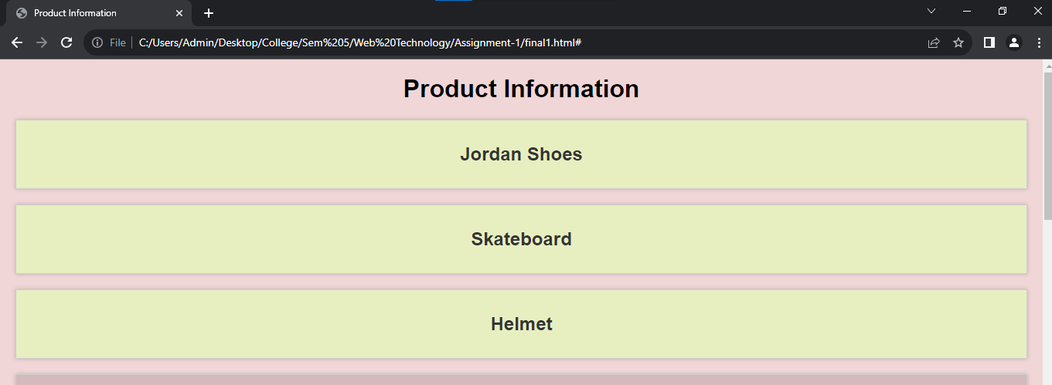

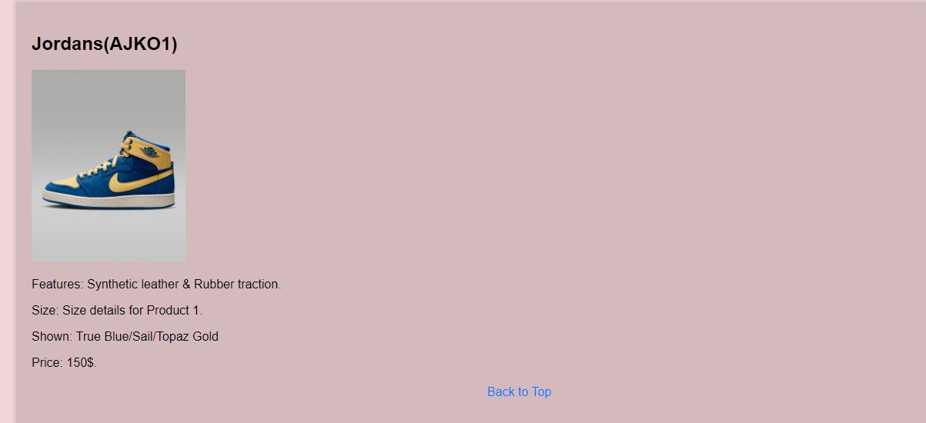

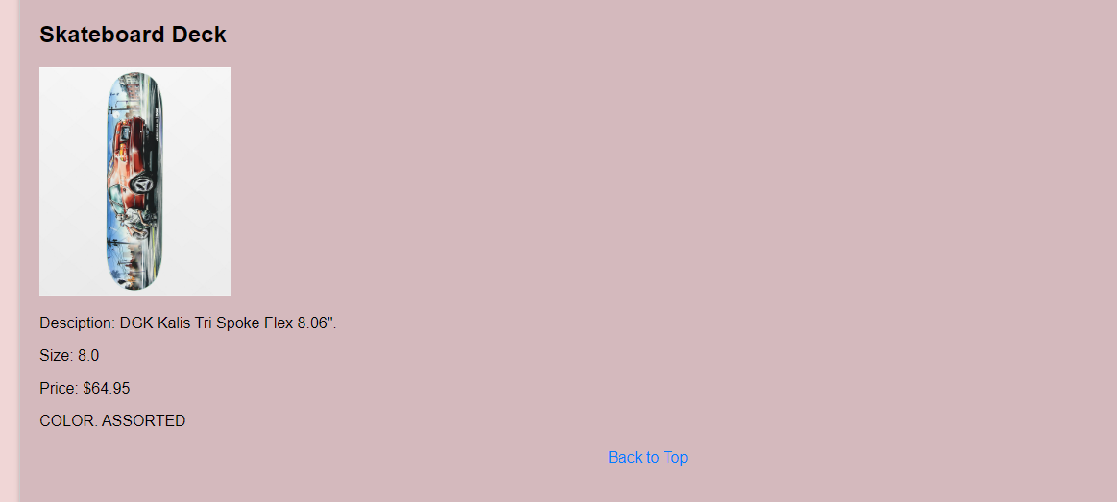

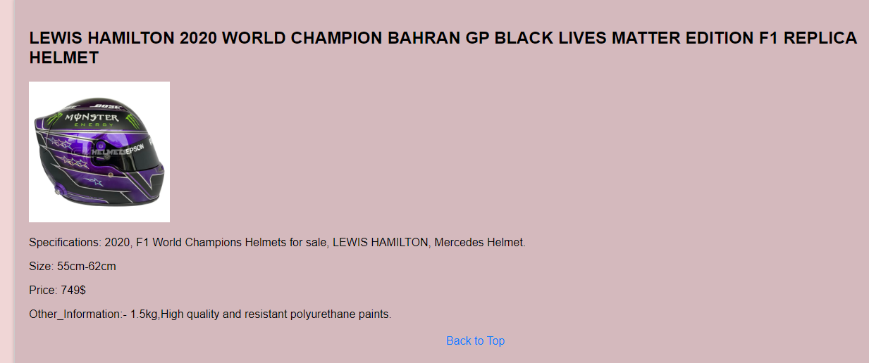

**Question – 2**

**HTML Code:**

<!DOCTYPE html>

<html lang="en">

<head>

<meta charset="UTF-8">

<meta name="viewport" content="width=device-width, initial-scale=1.0">

<title>Sports Page Styling</title>

<link rel="stylesheet" href="2.css">

<style>

p {

font-family: 'Segoe UI', Tahoma, Geneva, Verdana, sans-serif;

font-size: 18px;

color: rgb(0, 51, 255);

margin: 20px;

padding: 15px;

background-color: #f5e5e5;

border: 2px solid #d58f7f;

border-radius: 10px;

box-shadow: 0 2px 4px rgba(0, 0, 0, 0.1);

text-align: justify;

line-height: 1.5;

}

p:first-child {

font-weight: bold;

}

p:last-child {

font-style: italic;

}

</style>

<link rel="stylesheet" href="final2.css">

</head>

<body>

<h1>Sports Page</h1>

<p>Cricket, a bat-and-ball game that originated in England, is now a beloved sport worldwide. It involves two teams of eleven players each, with one team batting to score runs while the other bowls and fields to limit the runs scored by the batting team. The game is played on a circular or oval field, with a 22-yard pitch at the center. Cricket is celebrated for its strategic depth, thrilling matches, and the physical endurance it demands from players. It's a sport that beautifully blends strategy, skill, and athleticism.</p>

<table class="styled-table">

<thead>

<tr>

<th>Question</th>

<th>Answer</th>

<th>Additional Information</th>

</tr>

</thead>

<tbody>

<tr>

<td>What is Formula 1 racing?</td>

<td>Formula 1 is the pinnacle of motorsport, known for its high-speed races and

cutting-edge technology. Drivers in F1 are some of the most skilled and daring in

the world, pushing the limits of both their cars and themselves. The sport represents

the fusion of engineering excellence and driving prowess.</td>

<td>F1 cars can reach speeds of over 200 mph.</td>

</tr>

<tr>

<td>What makes F1 unique?</td>

<td>F1's glamorous and global nature sets it apart. The championship travels to diverse

locations, offering fans a taste of different cultures and climates. The drama and

unpredictability of F1, with its nail-biting overtakes and strategic battles, keep

fans on the edge of their seats. It's a sport that combines the thrill of speed with

the precision of strategy.</td>

<td>F1 races are watched by millions of fans worldwide.</td>

</tr>

</tbody>

</table>

<p>Badminton is a racquet sport played using racquets to hit a shuttlecock across a net. It can be played in singles (one player per side) or doubles (two players per side). The game is often played casually outdoors, but formal games are played on a rectangular indoor court. Points are scored by striking the shuttlecock with the racquet and landing it within the opposing team's half of the court. The shuttlecock, a feathered or plastic projectile, has a unique flight pattern that gives the sport its distinctive nature. The game requires excellent fitness, agility, strength, speed, and precision.</p>

</body>

</html>

**CSS Code:**

.styled-table {

width: 100%;

border-collapse: separate;

border-spacing: 0;

background-color: #f9f9f9;

border: 3px solid #0c0000;

border-radius: 15px;

}

.styled-table th, .styled-table td {

padding: 10px;

border: 1px solid #ccc;

text-align: center;

}

.styled-table th {

background-color: rgb(188, 173, 230);

color: rgb(14, 13, 13);

font-weight: bold;

}

.styled-table td {

background-color: #bac5ef;

color: #333;

font-family: 'Courier New', Courier, monospace;

font-size: 16px;

border-bottom: 2px solid #333;

}

**Output:**

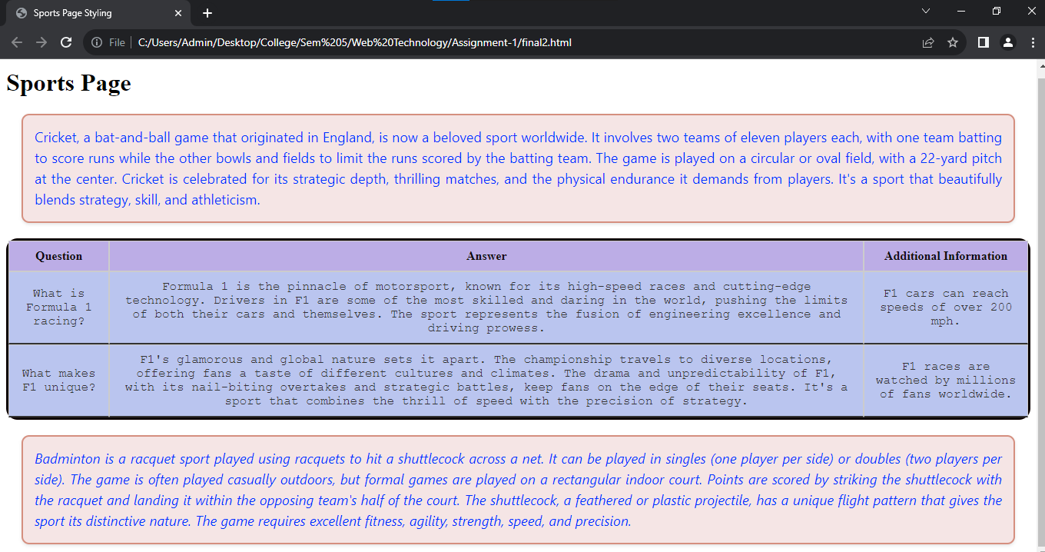

**Question – 3**

**Code:**

<!DOCTYPE html>

<html>

<head>

<title>Subjects</title>

<style>

table {

background-color: cyan;

width: 80%;

margin: 20px auto;

}

table, th, td {

border: 2px solid blue;

text-align: center;

padding: 8px;

}

th {

background-color: cyan;

}

</style>

</head>

<body>

<h1 style="color: blue; text-align: center">List of Course-wise Subjects</h1>

<table>

<tr>

<th rowspan="2">Sr. No.</th>

<th rowspan="2">Course</th>

<th rowspan="2">Subject</th>

<th colspan="2">Marks</th>

<th colspan="2">Category</th>

<th rowspan="2">Practical / Theory</th>

</tr>

<tr>

<th>Internal</th>

<th>External</th>

<th>Internal</th>

<th>External</th>

</tr>

<tr>

<td rowspan="4">1</td>

<td rowspan="4">MBA</td>

<td>Management Accounting</td>

<td>30</td>

<td>70</td>

<td>-</td>

<td>✓</td>

<td>Theory</td>

</tr>

<tr>

<td>Information Technology</td>

<td>30</td>

<td>70</td>

<td>-</td>

<td>✓</td>

<td>T and P</td>

</tr>

<tr>

<td>Basics of Marketing</td>

<td>30</td>

<td>70</td>

<td>-</td>

<td>✓</td>

<td>Theory</td>

</tr>

<tr>

<td>E-Commerce</td>

<td>50</td>

<td>-</td>

<td>✓</td>

<td>-</td>

<td>Theory</td>

</tr>

<tr>

<td rowspan="6">2</td>

<td rowspan="6">MCM</td>

<td>Visual Basic</td>

<td>30</td>

<td>70</td>

<td>-</td>

<td>✓</td>

<td>T and P</td>

</tr>

<tr>

<td>Internet Technology</td>

<td>30</td>

<td>70</td>

<td>-</td>

<td>✓</td>

<td>T and P</td>

</tr>

<tr>

<td>Network Technology</td>

<td>30</td>

<td>70</td>

<td>-</td>

<td>✓</td>

<td>Theory</td>

</tr>

<tr>

<td>VB.Net</td>

<td>30</td>

<td>70</td>

<td>-</td>

<td>✓</td>

<td>T and P</td>

</tr>

<tr>

<td>Linux</td>

<td>30</td>

<td>70</td>

<td>-</td>

<td>✓</td>

<td>T and P</td>

</tr>

<tr>

<td>ISA</td>

<td>50</td>

<td>-</td>

<td>✓</td>

<td>-</td>

<td>Theory</td>

</tr>

</table>

</body>

</html>

**Output:**

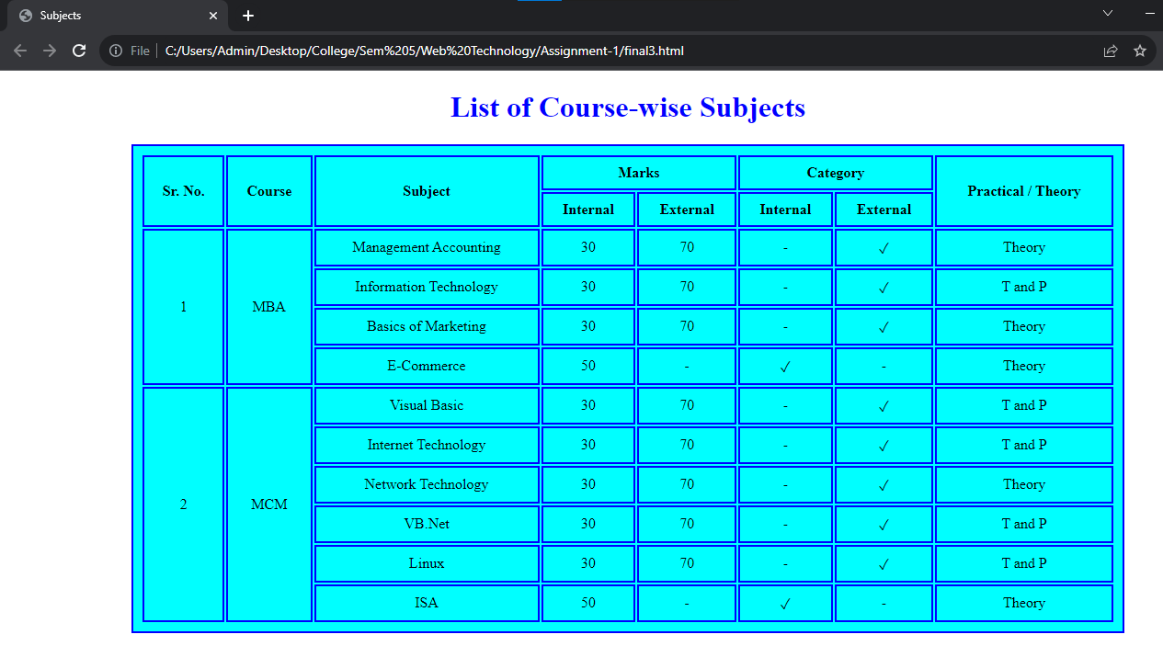

**Question – 4**

**Code:**

<!DOCTYPE html>

<html>

<head>

<title>Karan Shah</title>

<style>

body {

font-family: Arial, sans-serif;

}

a {

text-decoration: none;

color: green;

}

a:active {

color: red;

}

a:visited {

color: blue;

}

table {

border-collapse: collapse;

width: 80%;

margin: 20px auto;

background-color: #f2f2f2; /* Background color for the table */

}

table, th, td {

border: 1px solid #1d1c1c;

}

th, td {

padding: 10px;

text-align: left;

}

h1 {

text-align: center;

}

img {

max-width: 100px;

height: auto;

}

/* Added some styling for clarity */

.tab-content {

display: none;

}

.tab-content:target {

display: block;

}

/* Added radio buttons and labels for tabbed interface */

input[type="radio"] {

display: none;

}

.tab-label {

cursor: pointer;

}

.tab-label:hover {

color: red;

}

.tab-label:visited {

color: blue;

}

</style>

</head>

<body>

<table>

<tr>

<td colspan="3">

<h1>Karan Shah</h1>

<p style="text-align:center">“The biggest Risk in life is not taking any Risk”

― Mark Zuckerberg</p>

</td>

</tr>

<tr>

<td>

<a href="#content-objective" class="tab-label">Objective</a><br>

<a href="#content-personal" class="tab-label">Personal Information</a><br>

<a href="#content-family" class="tab-label">Family Information</a><br>

<a href="#content-education" class="tab-label">Educational Information</a><br>

<a href="#content-experience" class="tab-label">Experience</a><br>

<a href="#content-achievements" class="tab-label">Achievements</a><br>

<a href="#content-other" class="tab-label">Other</a><br>

</td>

<td>

<div class="tab-content" id="content-objective">

<p><b>Objective:</b>

To leverage my skills and expertise in Computer Science to contribute to

innovative projects, drive growth, and advance my career in a dynamic and collaborative

work environment. I am committed to continuous learning and delivering exceptional

results while fostering a culture of teamwork and creativity.</p>

</div>

<div class="tab-content" id="content-personal">

<h3>Personal Information</h3>

<p>

<br>Full Name: Karan Shah</br>

<br>Date of Birth: 01/01/2004</br>

<br>Nationality: Indian</br>

<br>Address: Ahmedabad,Gujarat,India</br>

<br>Phone: 9999999999</br>

<br>Email: karan.sce21@sot.pdpu.ac.in</br>

<br>LinkedIn: LinkedIn Profile</br>

<br>GitHub: GitHub Profile</br>

<br>Website: karan-portfolio.com</br>

</p>

</div>

<div class="tab-content" id="content-family">

<p>

<br>I come from a close-knit and supportive family. My family consists of:</br>

<br> - Parents: Mom and Dad </br>

<br> - Siblings: 1 </br>

</p>

</div>

<div class="tab-content" id="content-education">

<p><b>Educational Information:</b>: My academic journey includes a B-Tech Degree in

Computer Science from PDPU, graduating in 2025.

I also pursued additional courses and certifications in Web Development

to enhance my knowledge and skills.</p>

</div>

<div class="tab-content" id="content-experience">

<p>

<b>Experience:</b>I have 3 months of experience in Front-End Web Development. During this time,

I've had the opportunity to work on diverse projects and collaborate with talented

professionals. My experience includes working on various new and exciting projects,

which have contributed to my expertise in field of Web Development. I'm passionate

about this field and very excited to continue growing in my career.

</p>

</div>

<div class="tab-content" id="content-achievements">

<p>

<b>Achievements:</b> During my career journey, I've reached significant milestones, including the recognition of receiving several awards. These achievements are a testament to my unwavering dedication and relentless pursuit of excellence.I take immense pride in my consistent record of accomplishments and remain committed to the pursuit of excellence in all my endeavors.

</p>

</div>

<div class="tab-content" id="content-other">

<h1>Join me in this extraordinary journey as we explore new horizons together!</h1>

</div>

</td>

<td>

<div id="display">

<img class="circular--square" style="width:200px;height:auto;" src="Image.jpg" />

</div>

</td>

</tr>

<tr>

<td colspan="3">

<p><center>

<br><b>Phone Number:</b> +91 xxxxxxxxxx<br>

<br><b>Email:</b> karan.sce21@sot.pdpu.ac.in<br>

</center></p>

</td>

</tr>

</table>

</body>

</html>

**Output:**

